After preprocessing, the dataset contains 32,561 observations and 96 predictor variables. The increase in variables is due to one-hot encoding of categorical attributes such as work class, education, occupation, and marital status. This transformation converts categorical variables into numerical binary indicators that can be used by machine learning algorithms. The target variable for this classification task is income, which indicates whether an individual's annual income exceeds $50K.
Accuracy, precision, recall, and F1-score were used to evaluate model performance. Accuracy measures the overall correctness of predictions, while precision and recall help evaluate performance on the positive income class. The F1-score provides a balance between precision and recall.

Logistic Regression Results

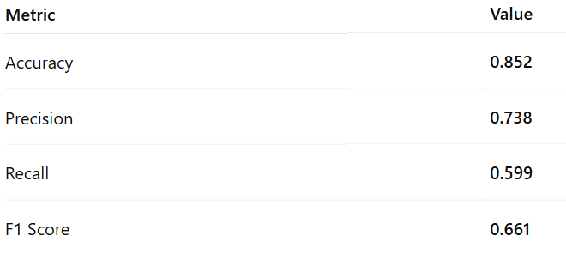

The Logistic Regression model achieved an accuracy of approximately 85%. The precision score of 0.738 indicates that when the model predicts that an individual earns more than $50K, it is correct about 74% of the time. The recall score of 0.599 suggests that the model correctly identifies about 60% of individuals who actually earn more than $50K. The F1 score of 0.661 reflects a moderate balance between precision and recall. Overall, Logistic Regression provides a strong baseline model for the income classification task.

Random Forest Results
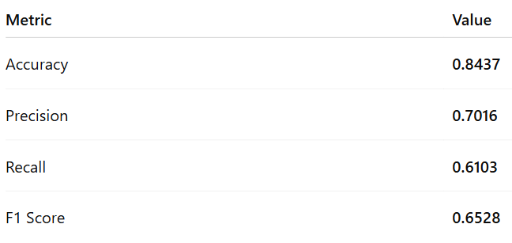

The Random Forest classifier achieved an accuracy of approximately 84.4%. The precision score of 0.702 indicates that about 70% of individuals predicted to earn more than $50K were correctly classified. The recall score of 0.610 shows that the model correctly identified about 61% of high-income individuals. Compared to Logistic Regression, Random Forest produced slightly lower overall accuracy but improved recall, meaning it was better at detecting individuals who earn more than $50K.

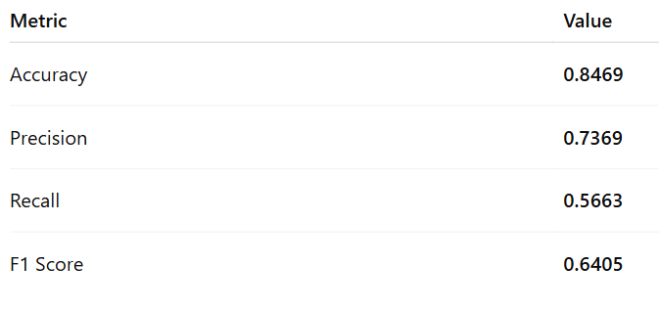

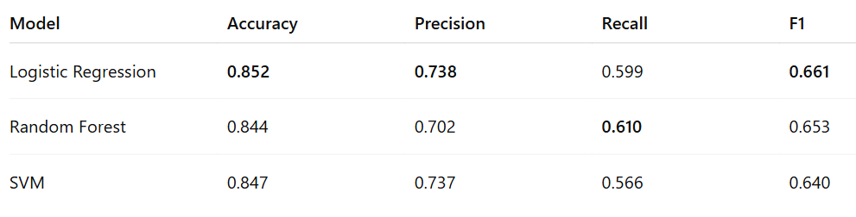
Model Comparison Table

Three classification models were evaluated: Logistic Regression, Random Forest, and Support Vector Machine. Logistic Regression achieved the highest overall accuracy (85.2%) and the highest F1 score (0.661), making it the best-performing model overall. Random Forest achieved slightly lower accuracy but produced the highest recall, meaning it was better at identifying individuals earning more than $50K. The SVM model produced competitive accuracy but lower recall, indicating that it missed more high-income individuals. Based on these results, Logistic Regression was selected as the best overall model for this classification task.

Confusion matrix 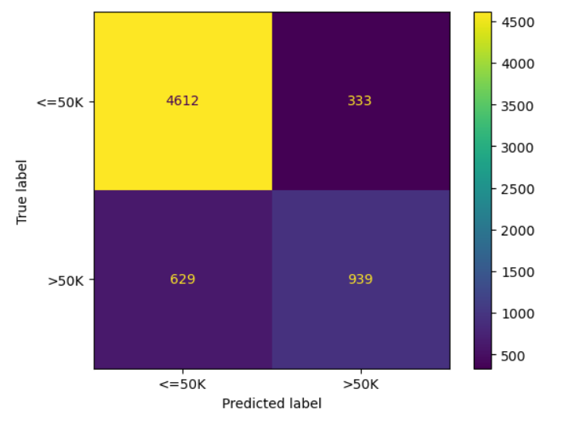

The confusion matrix provides a detailed breakdown of the classification results. The model correctly classified 4,612 individuals who earn less than or equal to $50K and 939 individuals who earn more than $50K. However, 333 individuals were incorrectly classified as earning more than $50K when they actually earn less, and 629 individuals who earn more than $50K were incorrectly classified as earning less. These results indicate that the model performs well in identifying lower-income individuals but has more difficulty identifying all high-income individuals.

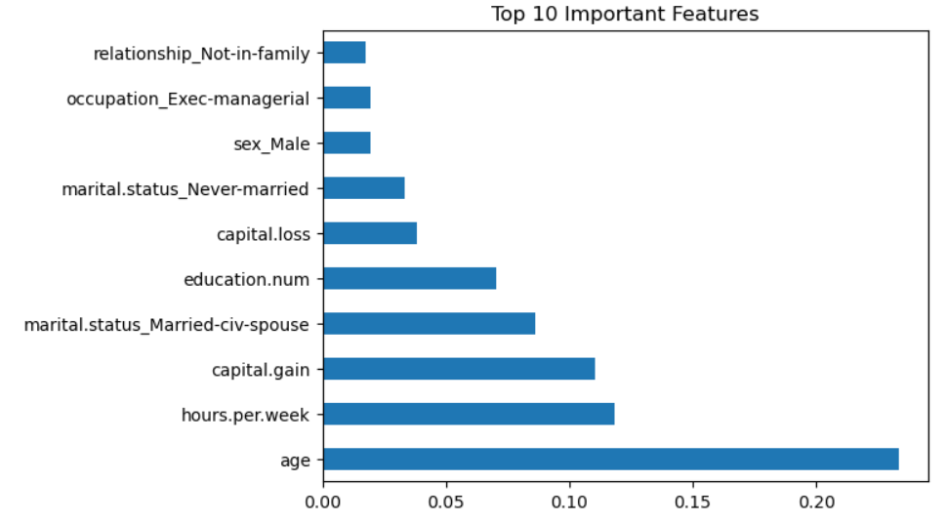
Feature importance analysis from the Random Forest model shows that age, hours worked per week, and capital gain are the most influential predictors of income classification. Individuals who are older, work more hours, and report higher capital gains are more likely to earn over $50K. Education level and marital status also contribute to income prediction, indicating that socioeconomic factors play an important role in determining income levels.

Deployment
The final model could be deployed by organizations or policymakers interested in understanding factors associated with higher income levels. For example, labor economists or workforce development programs could use the model to analyze employment patterns and identify characteristics linked to higher earnings. The model could be integrated into a decision-support system where demographic and employment information is input to estimate income classification. To maintain accuracy, the model should be retrained periodically as new workforce data becomes available.

